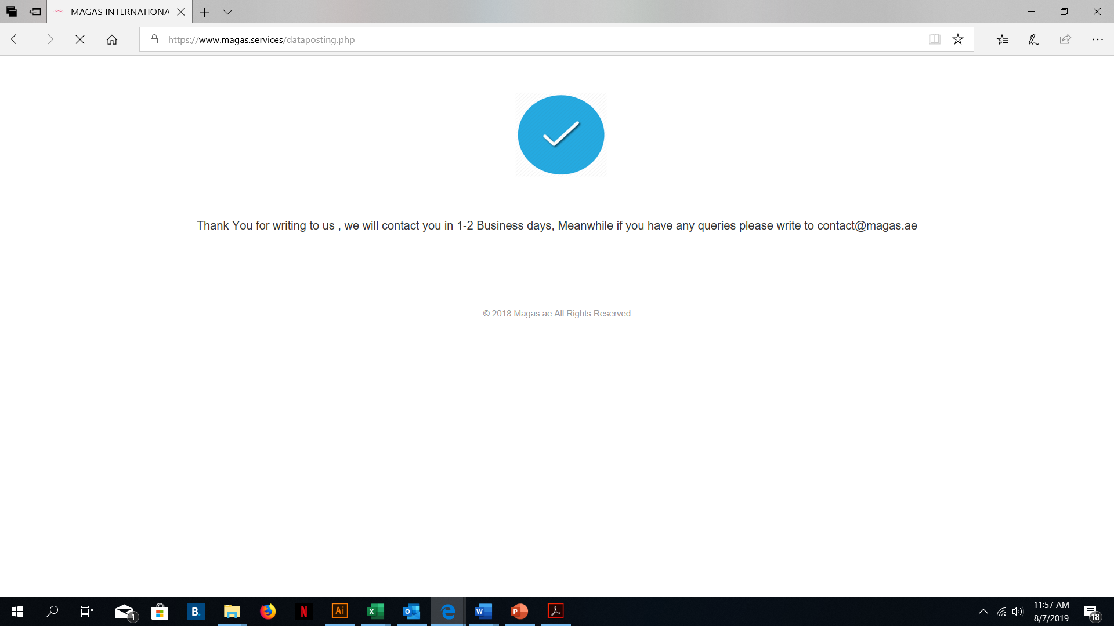

1. Change The text
2. The highlighted in yellow should be an automated feature just like it is on the <https://www.magasinternational.com/> website footer

------------------------------------------------------------------------------

Thank you for adding your service listing on [www.magas.services](http://www.magas.services), you will hear from us in 1-2 business days. If you have any other queries, please fill in the contact us form on <https://www.magas.services/contacts>

© 2010 – 2019 Magas International. All Rights Reserved.

-----------------------------------------------------------